**The renaissance of Eric Ravilious**

**埃里克·拉维利奥斯的文艺复兴**

（英文部分选自经济学人202200709期文化版块）

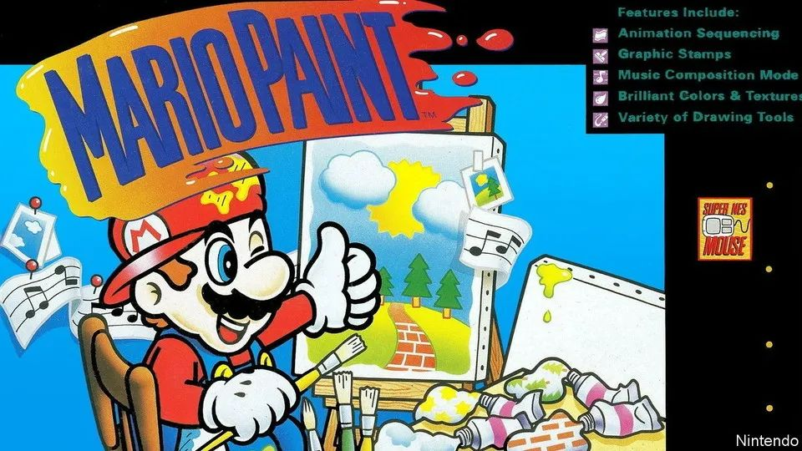

Culture | Let’s-a-van-Gogh

成为梵高！

“Mario Paint” **inspired a generation of creative geeks**

游戏《马里奥绘图》**启蒙了一代创意天才**

**The charming game of 1992** taught users basic animation and composition skills

**这款诞生于1992年的游戏风靡一时**，让玩家们学会了基础的动画和构图技巧

There are no quests, storylines or villains to be defeated. **When it was first released 30 years ago, in July 1992**, “Mario Paint” challenged gamers to design rather than destroy. Nintendo, which created the game for its Super Nintendo Entertainment System, succeeded in turning the making of digital art, animation and music into a joyous experience.

没有通关任务，没有故事线，也不需要击败反派角色。**三十年前的1992年7月，《马里奥绘图》问世**。这是一款艺术设计游戏，不需要闯关打怪。这款游戏是任天堂公司为旗下的超级任天堂娱乐系统而打造的，成功地将数字艺术、动画和音乐创作变成了一项愉快的体验。

“Mario Paint” will feel **familiar to anyone with experience of** the Windows 95 version of Microsoft Paint. Much like that program, **the main “Drawing Board” mode offers players a palette of colours and various tools with which to create whatever they please**. Compared with the 16m hues modern software provides for users, the choice of 15 shades is piffling. But **many of the instruments still used in digital-art software/ featured in the game**: players can copy or rotate an image, or use textured brushes, to create pixel-perfect art.

但凡用过Windows 95版“画图”程序的人都不会对《马里奥绘图》感到陌生。这款游戏和“画图”程序很像，**在主要的“画图板”模式中，玩家可以从调色板中选取颜色，还可以运用众多画图工具，自由创作【英译中，主语的选择，主被动】**。现在的画图软件有24位真彩色，相比之下，《马里奥绘图》提供的15种颜色实在有限。但**现在数字艺术软件中常用的很多绘图工具都在这款游戏中有所体现**：玩家可以复制、旋转图像或使用纹理刷创作出一幅完美的像素画。

The Supernes Mouse, which **came with** the console, allowed for greater control than the directional pads typically used in video games. Nintendo, which marketed “Mario Paint” to children as an educational tool, was aware that many players would never have used a mouse before. Their clever solution was to develop “Gnat Attack”—a fly-swatting mini-game within the main product which helped users hone their point-and-click co-ordination.

与电子游戏通常搭配的方向键相比，与《马力奥绘图》游戏主机一同发售的超级NES鼠标操纵感更强。任天堂把《马里奥绘图》定位为教育工具推荐给小朋友们，意识到了许多用户年纪还小，不会使用鼠标。为此，任天堂巧妙地在游戏中增设一款打苍蝇的小游戏——“蚊蝇攻击”，以帮助小朋友提升鼠标操作的协调性。

And what it lacked in sophistication, “Mario Paint” **made up for** in charm. Each stroke of a brush is accompanied by a bouncy sound effect. The cursor rotates through the colours of the rainbow. “Undodog”, a yelping cartoon pup, is on hand to help correct mistakes. A talented player could create detailed artworks: some produced impressive recreations of masterworks such as Salvador Dalí’s “The Persistence of Memory” or famous album art such as Bruce Springsteen’s “Born In The usa”.

《马力奥绘图》虽然专业性不够，但趣味性强。绘图刷的每次操作都会触发轻快的音效。光标在屏幕上画圈时会出现彩虹特效。一点击就会汪汪叫的卡通狗图标——“撤销狗” （Undodog），随时帮助玩家修正绘图错误。得心应手的玩家可以用《马力奥绘图》创作精致的作品。例如，某些玩家就试图重现大师杰作，成品令人惊叹。这些杰作包括萨尔瓦多·达利（Salvador Dalí）的名画《记忆的永恒》和布鲁斯·斯普林斯汀（Bruce Springsteen）的专辑《生于美国》的著名封面等。

注释：

An album cover (also referred to as album art) is the front packaging art of a commercially released studio album or other audio recordings. 专辑封面

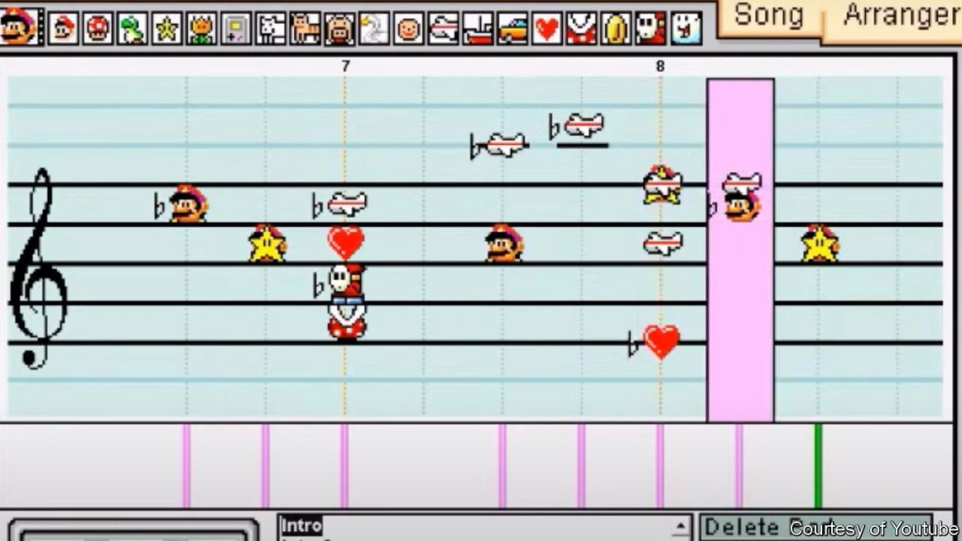

Yet what **set apart** “Mario Paint” **from** other games of its time was the capacity to create animations and compose music. Gamers could combine multiple frames of pixel drawings to create smooth moving characters known as “sprites”. To accompany these animations, they had the option of producing songs by combining 15 quirky sounds: a baby’s cry, for example, or a cat’s mewing.

和其他同时代的画图游戏相比，《马力奥绘图》最突出的优势是能够创作动画和音乐。玩家可通过合并多帧像素图创作行动流畅的动画“精灵”形象。而且，为配合动画效果，玩家还可通过组合系统自带的15种个性音效进行编曲，如婴儿的啼哭声和猫咪的喵呜等。

By the early 2000s, digital animation was pervasive on the internet. Web-series pioneers such as Mike and Matt Chapman, creators of “Homestar Runner”, have **cited** “Mario Paint” **as** an inspiration. A dedicated community of composers still exists, using unofficial emulations of the game to produce cover versions of songs by artists as diverse asbts, Daft Punk and Queen.

在2000年代初期，数码动画风靡网络。一众制作网络动画的先驱，如Homestar Runner的游戏开发者迈克（Mike Chapman）和他的弟弟马特·查普曼（Matt Chapman），皆表示《马里奥绘图》是他们创作的灵感来源。直到现在还有一群忠实的作曲家，他们在该游戏的非官方模拟器平台上对众多艺人的歌曲进行翻创，包括韩国男团防弹少年团（BTS），法国电子音乐组合蠢朋克乐队（Daft Punk）以及英国摇滚乐队皇后乐队（Queen）。

“Mario Paint” sold well and led to a sequel, “Mario Artist”. That game involved the creation of 3d computer graphics, a much fiddlier task than 2d imagery, and proved too unwieldy for many users. Perhaps the true successor of “Mario Paint” is “Super Mario Maker”, released in 2015, which lets users create and play their own Mario levels. The game includes its own version of an “Undodog” and an updated version of the fly-swatting exercise.

《马里奥绘图》的大卖让任天堂继而推出了《马里奥艺术家》。在这款游戏中，玩家可以创建三维图像，相比创作二维图像，需要更多精细操作，对很多玩家来说过于繁琐。《马里奥绘图》的真正接棒者也许是2015年发行的《超级马里奥制造》，用户可以自己创建和设置专属的马里奥游戏等级。该游戏创建了专属版本的 “撤销狗”，以及升级版的打苍蝇练习。

Some websites offer recreations of the composer mode, so you can tinker with songs using a browser; there are several imitation programs, too. But for the full experience, you will need to **track down** an original cartridge, mouse, console and a compatible television. For enthusiasts it is worth the effort. Modern digital-art software is designed to be professional, clean and utilitarian. “Mario Paint” prioritises fun instead.

一些网站提供了作曲家模式的小游戏，用户能够在浏览器上修改音乐；当然也有一些模拟程序。但是要想获得完整的游戏体验，还需找到原版的游戏卡盒、鼠标、游戏机和一台能够兼容的电视。不过对于马里奥发烧友来说，即便如此大费周章也是十分值得的。现代数字艺术软件的设计走的是专业化、简约化以及实用化路线，而《马里奥绘图》却把趣味性放在首位。